Natural Selection Worksheet

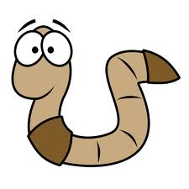**Read the following situations and identify the 5 points of natural selection.**

1. There are two types of worms: worms that eat at night (nocturnal) and worms that eat during the day (diurnal). The birds eat during the day and seem to be eating only the diurnal worms. The nocturnal worms are in their burrows during this time. Each spring when the worms reproduce, they have about 500 babies but only 100 of these ever become old enough to reproduce.

Population has variations. ___________________________________________________________

Some variations are favourable. _______________________________________________________

More offspring are produced than survive. ______________________________________________

Those that survive have favourable traits. ________________________________________________

A population will change over time. ____________________________________________________

Which worm will natural selection select FOR? _________________ AGAINST? _______________

1. 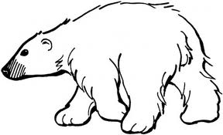There are three types of polar bears: ones with thick coats, ones with thin coats and ones with medium coats. It is autumn, soon to be winter. The temperatures are dropping rapidly and the bears must keep warm, or they will freeze to death. Many of the bears have had 2 or 3 cubs each, but due to the extreme temperatures, many mothers only have one cub left.

Population has variations. ___________________________________________________________

Some variations are favourable. _______________________________________________________

More offspring are produced than survive. ______________________________________________

Those that survive have favourable traits. ________________________________________________

A population will change over time. ____________________________________________________

Which bear will natural selection select FOR? _________________ AGAINST? _______________

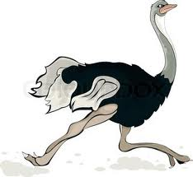

1. In ostriches, there are two types: ones that run fast and ones that run slowly. The fast birds can reach speeds of up to 65 kilometers an hour. Jackals love to eat ostriches, and they can reach speeds of between 50-65 kilometers an hour. A flock of ostriches will lay approximately 10 eggs (each mother only lays one) but rodents break into the eggs and eat the baby ostriches before they hatch.

Population has variations. ___________________________________________________________

Some variations are favourable. _______________________________________________________

More offspring are produced than survive. ______________________________________________

Those that survive have favourable traits. ________________________________________________

A population will change over time. ____________________________________________________

Which ostrich will natural selection select FOR? _________________ AGAINST? _______________

1. 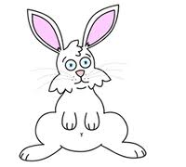There are two types of rabbits: those that only eat grass and those that eat only berries and flowers. A drought occurs one year. The plants have difficulty producing flowers and berries and they can only try to keep themselves green. The rabbits have had babies all year long, but many are eaten by foxes or hawks. Due to the drought, many have starved to death.

Population has variations. ___________________________________________________________

Some variations are favourable. _______________________________________________________

More offspring are produced than survive. ______________________________________________

Those that survive have favourable traits. ________________________________________________

A population will change over time. ____________________________________________________

Which rabbit will natural selection select FOR? _________________ AGAINST? _______________

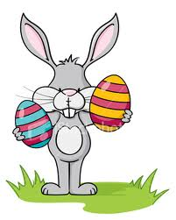

**Natural Selection of the Easter Bunny**

Easter Bunnies are only found on Cottontail Island. One way in which they are different from other rabbits is that they lay eggs, much like a platypus. Unlike the platypus, Easter Bunny eggs contain chocolate and have very colourful designs. Like all bunnies, they are herbivores.

Dogs are their chief predator. They will eat both the bunnies and their eggs. The chocolate in the eggs is poisonous to dogs. If an egg contains enough chocolate, the dog may become very sick, or even die. Hatched bunnies escape by running away from the dogs.

Questions

1. What is the main selective agent which acts on the Easter Bunny population?
2. List three variations which would help the bunnies to survive more easily in their environment, and explain how each would be an advantage to the bunny.
3. How do you think the Easter Bunny population will change over time?
4. Recently, humans arrived on Cottontail Island. Needless to say, every spring, they go out collecting the eggs of the Easter Bunny. Explain how this might affect the Easter Bunny population. Which bunnies would be better suited to adapt to this change in their environment?
5. What effect does the amount of variation in a population have on the ability of that population to adapt to a change in the environment?